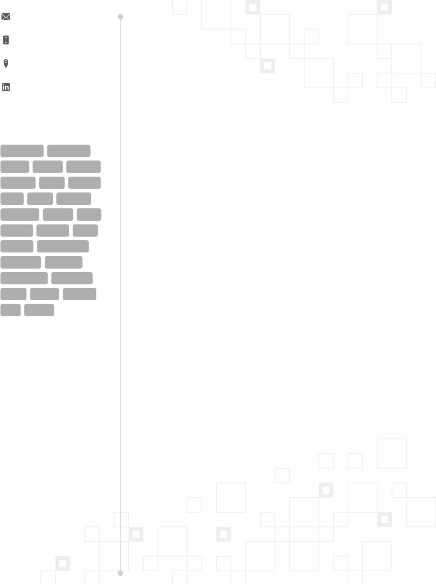{email}

{phone}

{location}

{LK}

 **SKILLS**

JavaScript TypeScript

React Redux Node.js

Express Nest Next.js

Vue Nuxt Angular

ChakraUI HTML CSS

Python Django PHP

Laravel Ruby on Rails

REST API GraphQL

PostgreSQL MongoDB

AWS Azure Testing

Git CI/CD

 **EDUCATION**

**{university-degree}, {university-major}**

{university-name}

*{university-duration}*

{name}

{headline}

A passionate and proactive software engineer with 10 years of professional experience, adept in bringing forth expertise in development and maintenance of software products, puts primary focus on keeping clear communication and close collaboration with the team to bring success to projects. A strong background in web development using JavaScript and other advanced technologies aids in this endeavor.

 **WORK EXPERIENCE**

**{position}**

{company}

*{duration}*, *United States*

*Achievements/Tasks*

 Developed and maintained robust software solutions for a variety of industries, including healthcare, e-commerce and real estate using modern JavaScript stacks especially React.

 Drove the frontend development of a geospatial data visualization and analysis software from ideation to launch, using Typescript, React.js, Node.js/Express.js, GraphQL and MapboxSDK.

 Incorporated new features into the people appreciation platform using modern web frameworks, especially Vue.js and Laravel.

 Built a rebranded version of an e-commerce platform with higher performance and better accessibility using Next.js, Nest.js, MongoDB and AWS to increase the customer satisfaction by 25%.

 Set up and followed best coding practices and standards to ensure high code quality with at least 75% of coverage and less than 1% of duplicatation through SonarCloud.

 Took initiative in mentoring 2 junior engineers in the team, by sharing knowledge on the industry standards & best practices to facilitate their professional growth.

*Tech Stack : JavaScript, TypeScript, React, React Hooks, Redux, React Query, React Native, GraphQL, Node.js, Express.js, Next.js, PostgreSQL, MongoDB, AWS, Jenkins, Jest, Mocha*

**{position}**

{company}

*{duration}*, *United States*

*Achievements/Tasks*

 Committed to developing home and solar energy management system for web & mobile platforms by providing real-time consumption data using TypeScript, React and Node.

 Fostered close collaboration with cross-functional teams to design and implement

innovative features within the car sales platform, such as an automated listings.

 Created visually captivating and pixel-perfect user interfaces by leveraging Figma designs, and focusing on ensuring user accessibility and search engine optimization.

 Contributed to the in-house UI library to create reusable components using React, TypeScript and Storybook that saved over 100 hours of development time per month.

 Integrated GraphQL into existing web services using Apollo to enable eﬃcient data manipulation for authentication, product listing, orders and payments.

 Enhanced the developer experience by turning majority of legacy JavaScript codebase into Typescript and also introducing ESBuild for 4x faster module build time.

 Strictly followed the pyramid testing approach to ensure over 80% code coverage, utilizing React Testing Library and Jest for unit/integration testing and WebdriverIO/Cucumber for e2e testing.

*Tech Stack : TypeScript, React, Node.js, Storybook, Figma, GraphQL, Datadog, TDD, Git*

*Page 1 of 2*

** **WORK EXPERIENCE**

**{position}**

{company}

*{duration}*, *United States*

*Achievements/Tasks*

 Joined an early stage healthcare startup to build an online pharmacy platform that helps simplify prescription management and delivery.

 Played a key role in the development of Optum Storefront application by demonstrating proficiency in utilizing React/Redux, Typescript and Node.js.

 Closely communicated with the clients to incorporate their feedback into the platform and to ensure the product is optimized for the best customer experience and follows the healthcare compliances.

 Collaborated with the design team to transform wireframes and mockups into 100% functional and appealing user interfaces, adhering to best practices and design patterns.

*Tech Stack : JavaScript, TypeScript, React, Redux, Node.js, Stripe, Lighthouse, Sentry, Jest/Mocha*

**{position}**

{company}

*{duration}*, *United States*

*Achievements/Tasks*

 Honed expertise in software engineering through active participation in the development of Oﬃce 365 products and several marketing websites, leveraging a wide range of advanced technologies including Angular and Python.

 Received strong mentorship from experienced engineers on the team by participating in code pairing and review processes.

 Demonstrated continuous improvement in technical skills and interpersonal communication.

*Tech Stack : HTML, CSS, JavaScript, jQuery, Angular, Python, Django, REST API, MySQL, Git*

**

*Page 2 of 2*